BUILDING ACCESS TO EDUCATION SUMMIT
STRATEGIC PLANNING RESOURCES
Arizona
California
New Mexico
Texas

Resource 1: Building acceleration & advancement - Build a Heart case

Approaches for Emotional Selling
By Wendy Connick
Updated April 30, 2017
The vast majority of prospects buy based on emotion, not logic. They decide to buy because it “feels right,” then use logic to justify the decision to themselves. So the better you are at making an emotional connection between the prospect and whatever you're selling, the easier you'll find it to close sales.
Your job as a salesperson is to help prospects see the benefits that they'll gain from owning your product.
Benefits all have an emotional hook; that's what makes them different from features and that's why they are effective for selling while reciting a list of features just makes a prospect's eyes glaze over. You can and should start the benefit-connection process right from the first moment of contact. This will usually happen during a ​cold call to the prospect.
During your cold call, don't start by pushing your product's benefits. Instead, start by talking about YOUR benefits. At this point the prospect doesn't know or care about your product; your first step must be to show why you are a reliable source of information. The prospect has to believe in you first before he'll believe what you have to say about your product. So start by telling your prospect what you do, in a compelling way. Don't load your introduction with technical terminology. Remember, the goal is to connect on an emotional level, not a logical one.
For example, if you sell insurance, your introduction might be that you give your customers peace of mind about the future.
There are two potential approaches for emotional selling: the positive approach and the negative approach. The negative approach is far more commonly used by salespeople. Essentially, it means presenting your product as a cure or prevention for the prospect's biggest pain.
A positive approach, on the other hand, presents the product as something that will cause good things to happen in the future. Most prospects respond better to one approach or the other, so it's a good idea to probe early on as to which type of prospect you have.
The best time to determine which approach to use is early in your presentation, as part of your qualifying questions. It's often safest to start with emotionally positive questions, as your prospect is likely to find them less intrusive than negative questions. Positive qualifying questions might include, “Where do you see yourself a year from now? What do you hope to gain from this meeting? How long have you been thinking about making a purchase?” and so on. These questions touch on his positive emotions related to the product and give you some clue as to his expectations.
Negative questions elicit a fear reaction, so some prospects will be touchy about answering them. These questions might include, “What's your biggest problem right now? How long have you had this problem? How important is it to you to resolve it?” and so on. You can see that some of the positive and negative questions are quite similar: for example, “How long have you been thinking about making a purchase?” and “How long have you had the problem?” are pretty close.
The difference is that the first one puts a focus on what the prospect hopes to gain, while the second focuses on an issue that he wants to solve. The first elicits hope, while the second elicits fear.
Once you've covered the basics and learned a bit about your prospect, you can make your emotional connections more specific for the prospect. For example, if you learn that he is considering buying insurance because his wife is worried about being left without financial support, you can ask something like, “How do you think Marie will feel about this policy option?” By using his wife's name in connection with the product, you make it far more real to him and he'll start picturing what will happen after he buys from you – which makes it far more likely that he will, in fact, decide to buy.

Resource 2: Building Business Case
Arizona | https://statusofwomendata.org/wp-content/themes/witsfull/factsheets/factsheet-arizona.pdf
California | https://statusofwomendata.org/wp-content/themes/witsfull/factsheets/factsheet-california.pdf
New Mexico | https://statusofwomendata.org/wp-content/themes/witsfull/factsheets/factsheet-new-mexico.pdf
Texas | https://statusofwomendata.org/wp-content/themes/witsfull/factsheets/factsheet-texas.pdf

Resource 3: Case Study Challenge
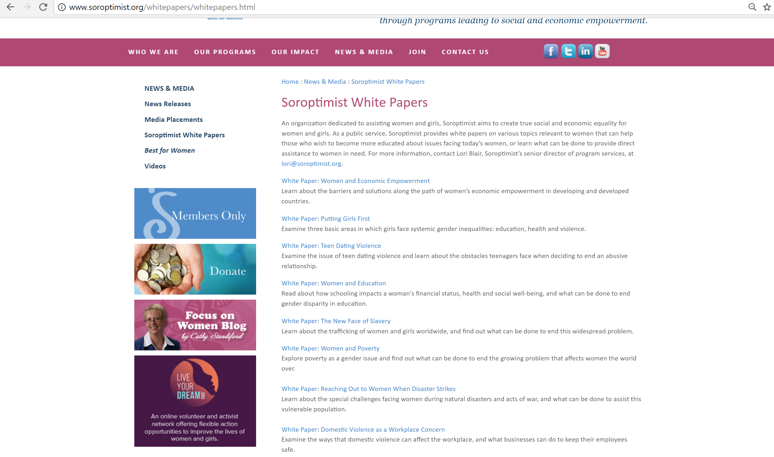

Resource #4: Calculate the Impact

Resource 5: Share your Successes

