PowerPoint® Cheat Sheet
Effective 6/1/18 – PowerPoint 2016 version. Many commands also available in earlier versions.
How to add items to your Quick Access Toolbar  Click this drop-down to open window for customization.  Click More Commands to see a full list of choices. | The most frequently used PowerPoint shortcuts  To do this Press  Create new presentation Ctrl+N  Make selected text bold. Ctrl+B  Change the font size for selected text. Alt+H, F, and then S  Change the zoom for the slide. Alt+W, Q  Cut selected text, object, or slide. Ctrl+X  Copy selected text, object, or slide. Ctrl+C  Paste cut or copied text, object, or slide. Ctrl+V  Undo the last action. Ctrl+Z  Save the presentation. Ctrl+S  Insert a picture. Alt+N, P  Insert a shape. Alt+H, S, and then H  Select a theme. Alt+G, H  Select a slide layout. Alt+H, L  Go to the next slide. Page Down  Go to the previous slide. Page Up  Go to the Home tab. Alt+H  Move to the Insert tab. Alt+N  Start the slide show. Alt+S,B  End the slide show. Esc  Close PowerPoint. Alt+F, X  There are many more keyboard shortcuts. For a full list, search the online help for “Shortcuts”.

Customize Ribbons – Your “menus”  Right click on Ribbon tab, then click Customize the Ribbon.  THEN…  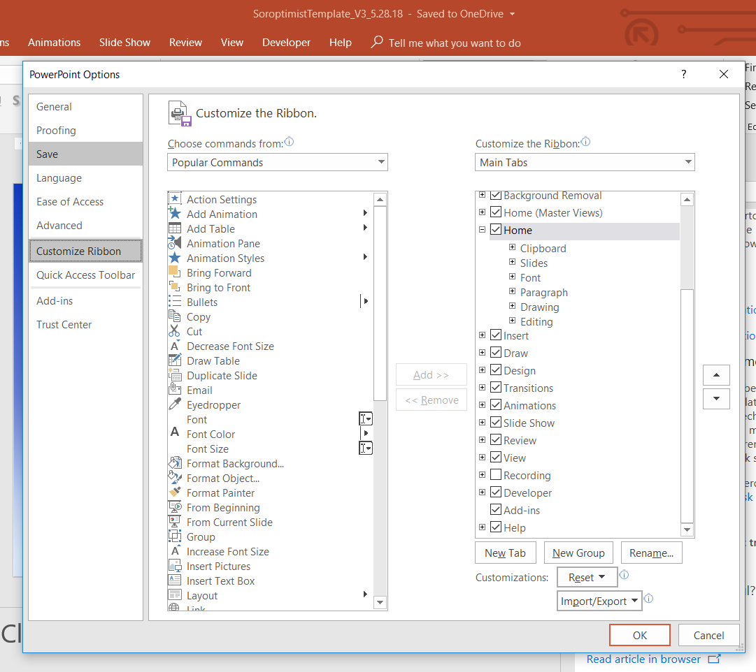  Modify the Ribbon using this window and click OK. | Use access keys to get to ribbon by using Key Tips  - Press Alt. The Key Tips appear in small squares by each ribbon command.  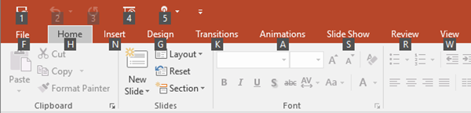  - To select a command, press the letter shown in the square Key Tip that appears by it. For example, press F to open the File Tab; H to open the Home Tab; N to open the Insert Tab, and so on.  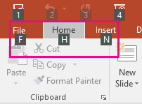  Depending on which letter you press, you may be shown additional Key Tips. For example, if you press Alt+F, Backstage view opens on the Info page, which has a different set of Key Tips.
Navigate the ribbon with only the keyboard
To get to the ribbon, press Alt, and then, to move between tabs, use the Right Arrow and Left Arrow keys OR to go directly to a tab on the ribbon, press one of the following access keys.
To do this | Press
Open the File page. | Alt+F
Open the Home tab. | Alt+H
Open the Insert tab. | Alt+N
Open the Design tab. | Alt+G
Open the Transitions tab. | Alt+T
Open the Animations tab. | Alt+A
Open the Slide Show tab. | Alt+S
Open the Review tab. | Alt+R
Open the View tab. | Alt+W
Open the Tell me box. | Alt+Q, and then enter the search term

